Height Mapping With Shaders

CS 457: Computer Graphics: Shaders

Nicholas Skinner

[Skinnern@oregonstate.edu](mailto:Skinnern@oregonstate.edu)

Video Link: <https://media.oregonstate.edu/media/t/0_aaj15253>

**Final Project Proposal CS 457**

For the final project for this class, I would be interested in applying a texture map to an object. This would involve reading in a series of texture maps to understand the normal, the height the roughness as well as the abelto that should be applied to the surface. After applying these items, I would then give a light on the shader slider panel for the user to control to try to show off the effect the map has on the texture. If all goes well, the texture should look like it has bumps and ripples in a realistic manner.

The current concept that I have for this project is modeling a brick wall, onto a cube or quad, or some shape with flat surfaces that will best display what is happening. I will map each of the textures, which I understand to represent:

Albedo = Diffuse Map

Normal = Normal bump / bump map

Roughness = ‘gloss’ - manages reflections

Height = displacement map

After Applying these textures, I will need to create a light that will highlight specific maps of the object, and make its xyz movements controllable by the user. After implementing both of these elements, and ensuring that they work correctly, I believe that the base project could be considered done, but I have a few extended goals that I’d really like to implement for the project if I have the time.

An extended goal for this project could be to implement a splatmap of some kind, and apply a second texture to make a more realistic scenario, like the bricks being adjacent to dirt or grass. I think this would be a great addition as it could extend my current system to be a more realistic display, where objects can appear overlayed on top of eachother. With this system I could also use Noise to create some spots of the second material nearby to make some imperfections within the splatmap. I hope Time permits me to reach this state.

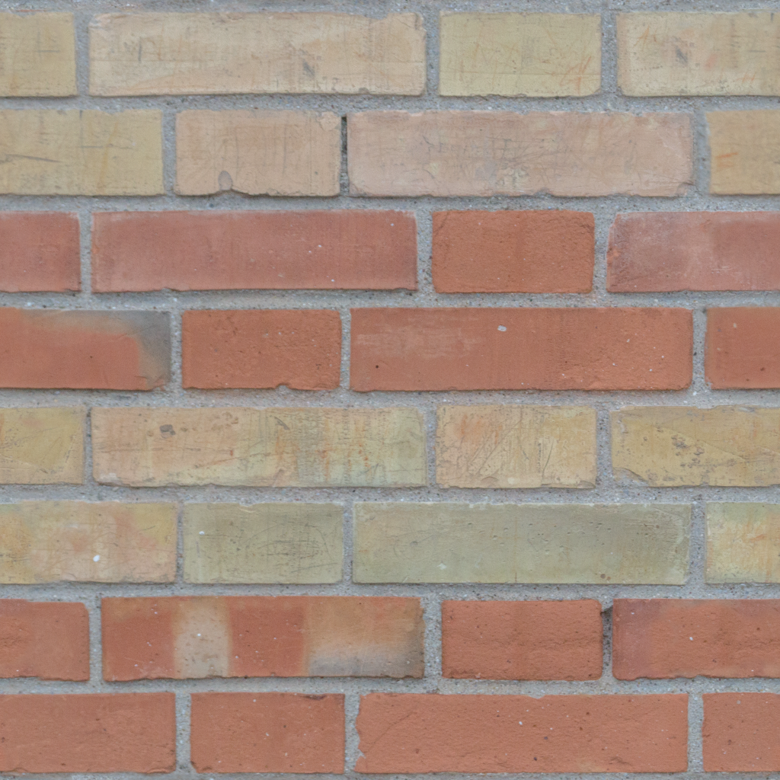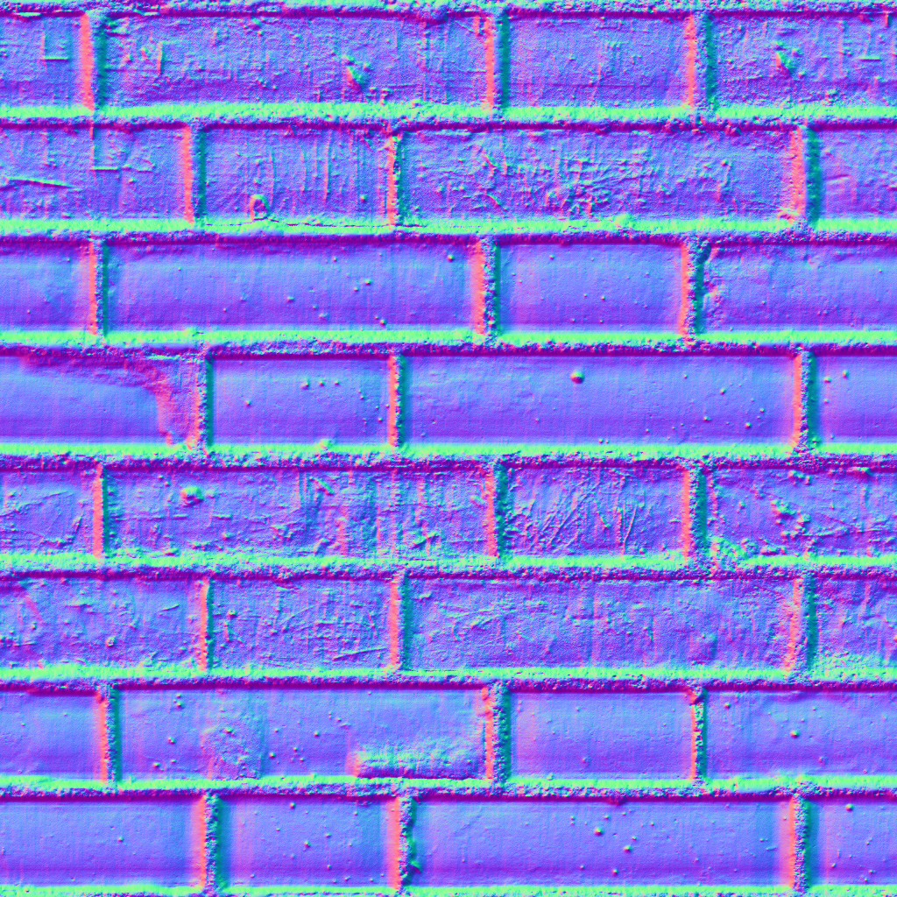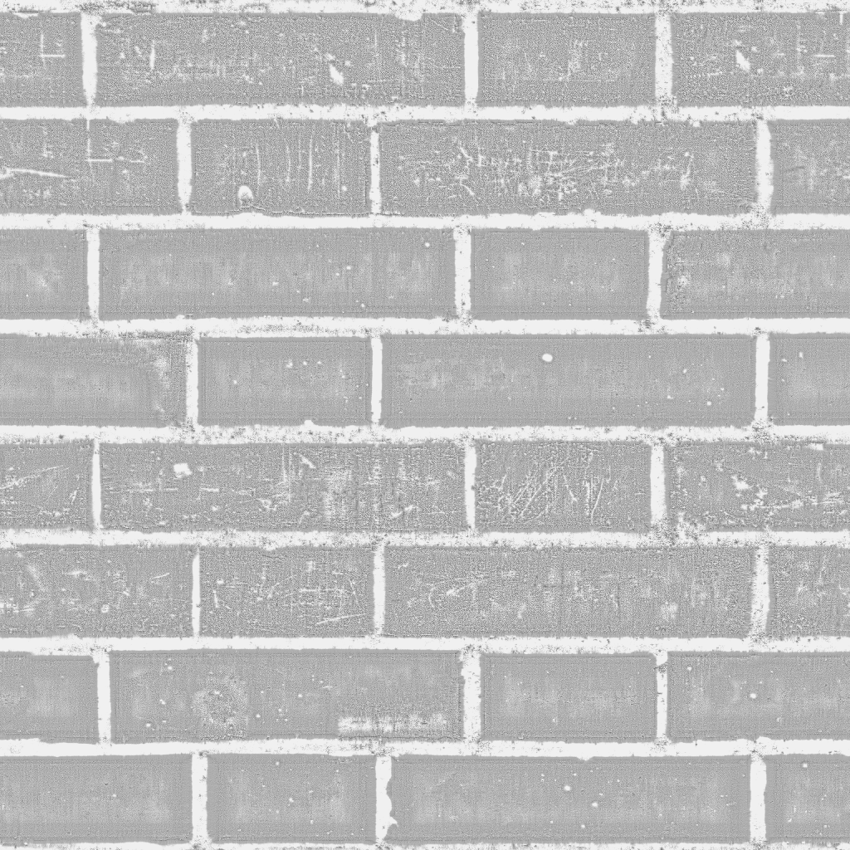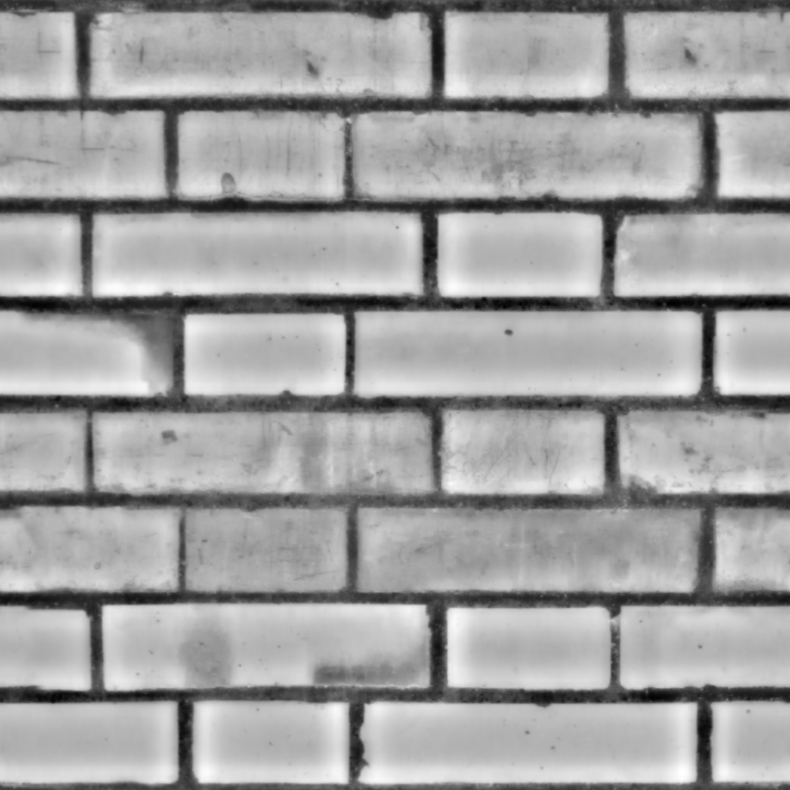

**Final Project Submission CS 457**

For my final project, I had aimed to use texture mapping on an object to display a texture with some height, normal, and roughness mapping. I feel like I’ve accomplished what I set out to do, and I feel like I’ve accomplished the stretch goals I had set for myself on the proposal, without further ado, my final project:

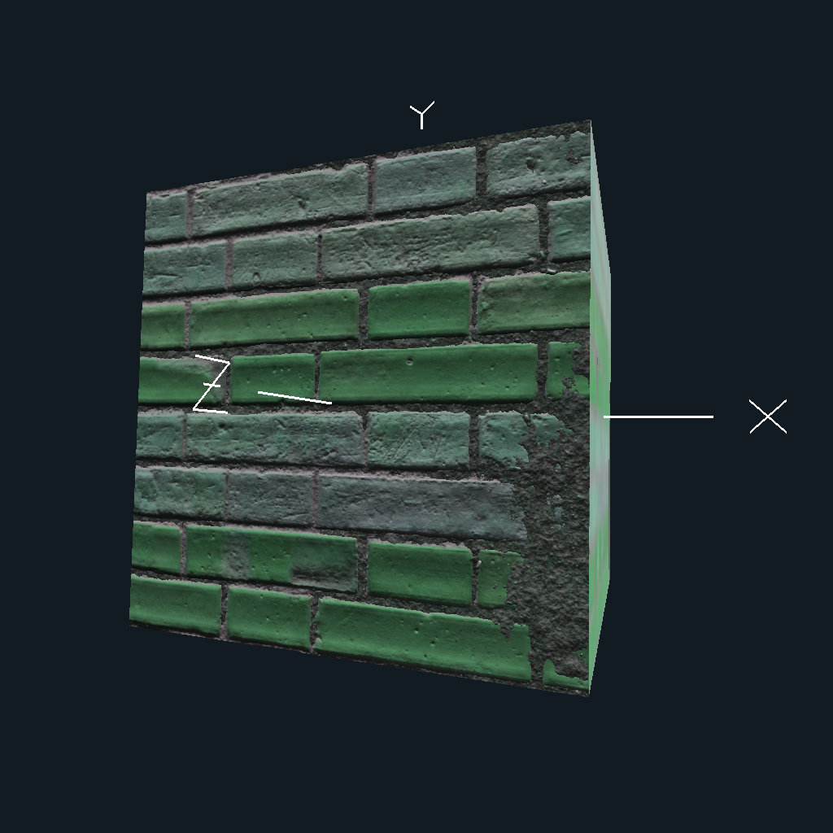

As you can see, it is a height-mapped brick wall with some height-mapped dirt on, which was applied through a splatmap. I thought this was a really neat project to end the term on, as it had tested a number of concepts I had learned through the term, but also gave me a chance to learn some new ones.

In my project proposal, I had noted that I wanted to use texture mapping files to create an object that appears to have bumps and ripples in a somewhat realistic manner. I think I had overestimated the effect that some of these would give though, as when I applied them, I had to zoom in much closer to get a really good look at what was happening with the lighting.

When attempting to create a solution for my project proposal, I ran into a wall right away. How do I import these files, and how do I apply them to my project? Multiple tutorials pointed me towards the fragment shader, and using sampler2D’s to store my texture files until they needed to be called. When applying my first textures, I used a vec3 to contain what came out of placing my texture file in the texture() method, to use this method I needed to grab the vertex shaders gl_multiTexCoord0.st, so I could properly map my textures across the object. Next, I needed to calculate the lighting for the object, so I send it to a function called CalculateTheLighting, which will accept our texture vec3’s for our normal, diffuse, and specular values, and crank out a vec4 that should properly display how the object is intended to interact with lighting.

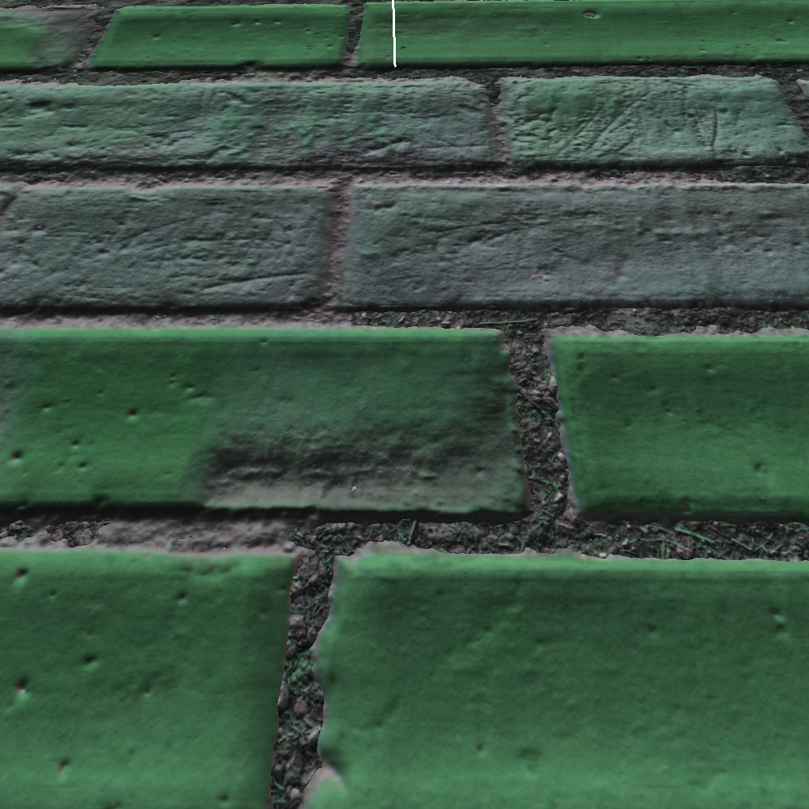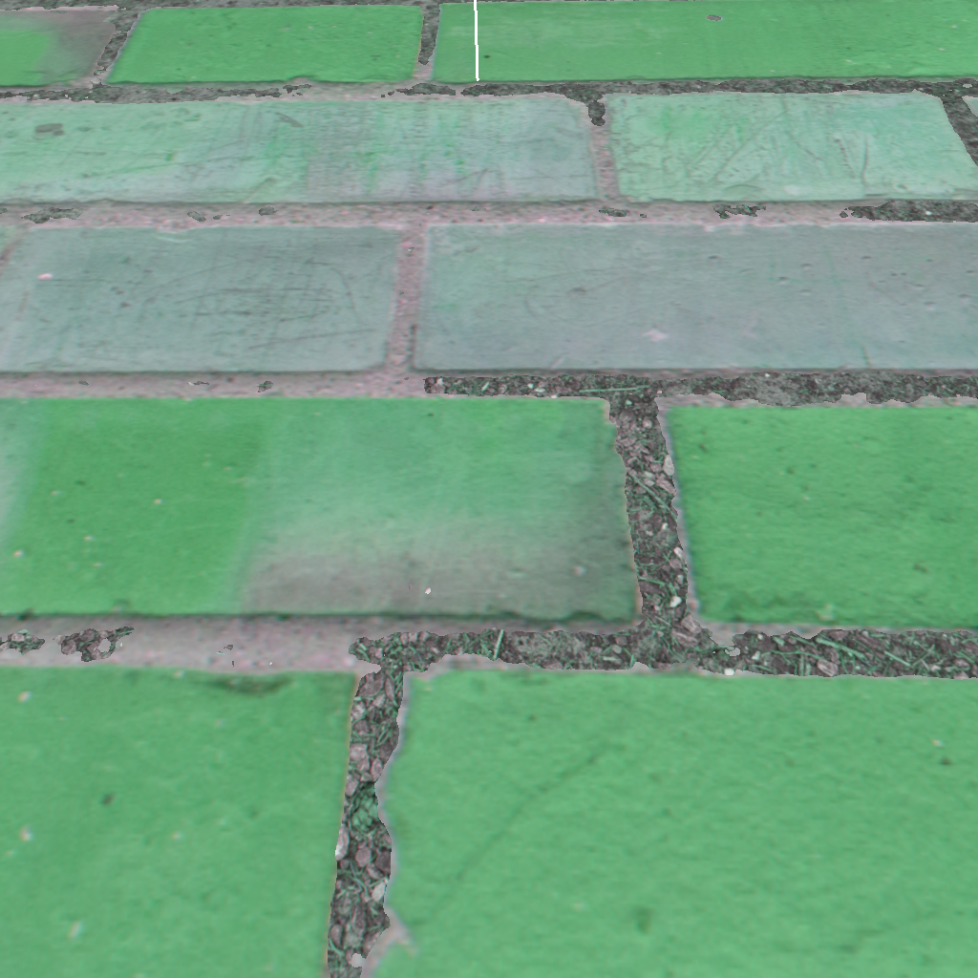

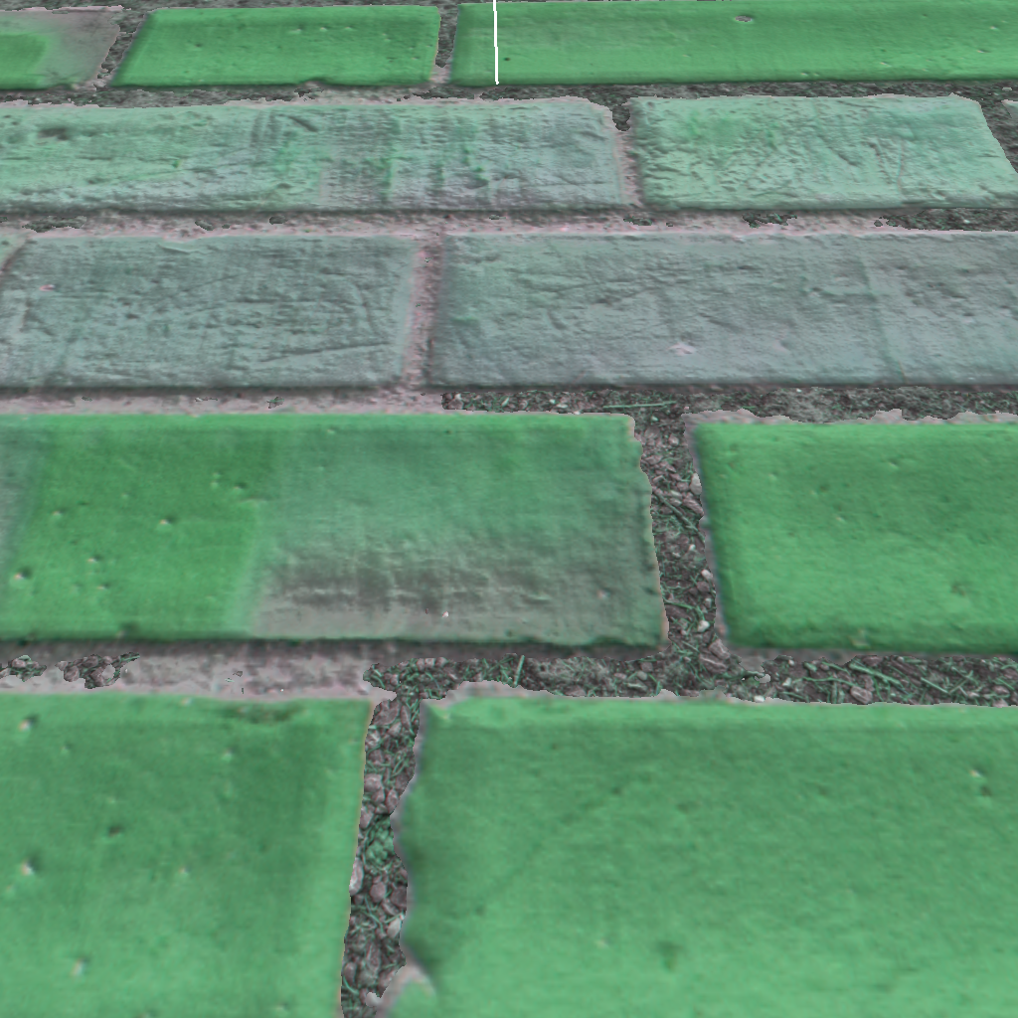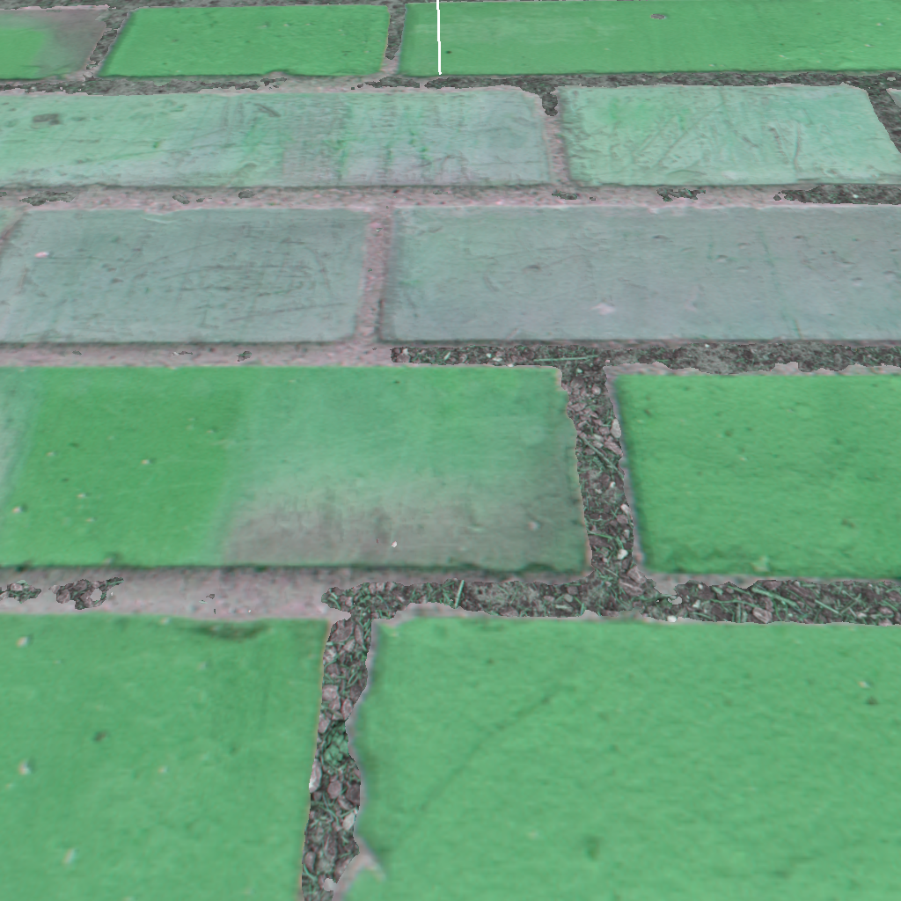

The First part was done, Lighting looked different when it shined on different parts of the brick cube I had constructed, but my extra goals for the project were still on the horizon. Adding an additional texture was easy, I just needed to apply the same procedure I created for the first object into a second one, but the difficulty shot up a bit when learning about splatmaps, and how to apply them.

I found a simple solution by using the heightmap times the splat map value to determine what textures should reside in what position, red should signify my brick wall, and green should signify the dirt covering it. This allowed for both textures to be represented on the object, and give a natural look of transitioning textures.



This was a simple solution to the splat mapping issue, and it created a really neat effect, a giant glob of dirt on one side of my object, and then some of the gaps between bricks on my object were filled up with dirt, giving it a less polished, and more natural look (from a distance.). It also helped that the conversion to a dirt surface is gradual, little specks of dirt become lines, then become the giant glob.

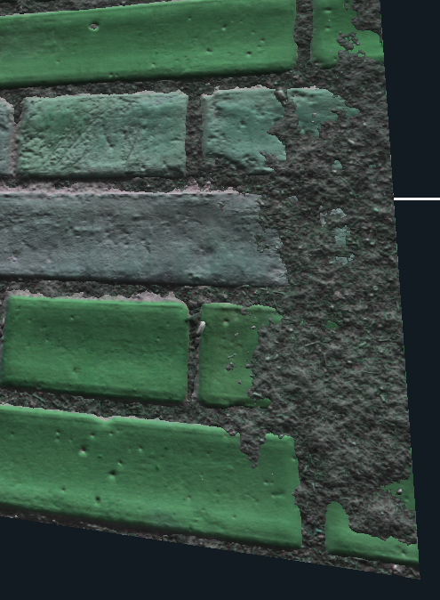

Overall, I think this was a very fun and achievable project, texture mapping was not too difficult, and gave a really satisfying end result. The Height mapping portion was not too bad, as the main use of it was more so focused on helping the splatmap decide where to go. The splatmap portion was super easy and was only used for one segment. I’m really happy with the project I decided on, and what it ended up turning out as. The only thing I’m coming out of this questioning is how some of these texture mapping showcases get such good pop out on their mapping, their rocks look really nice and actually pop out of the shape a ways.